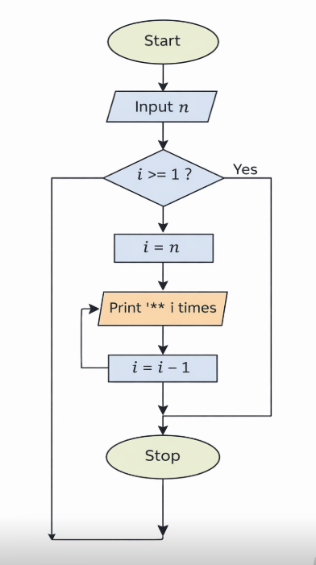
ALGORITHM
1. Start
2. Input integer n (number of rows)
3. Set i = n
4. Repeat while i >= 1:
Print i stars (*) in one line
Move to next line
Decrease i by 1 (i = i - 1)
5. Stop
7.1.1 INVERTED STAR PATTERN

